**Assignment2 - Pacman Game**

This game was created as part of the course Internet Programming Environments, April 2021.

**Developers:**

* Lahan Barmocha, 205590656 , לחן ברמוכה, [Email](https://github.com/Web-Development-Environments-2021/Assignment2_313584294_205590656/blob/master/barmocha@post.bgu.ac.il),[Git](https://github.com/Barmocha),[Linkedin](https://www.linkedin.com/in/lahan-barmocha-3350ab156/)
* Nicole Dezoraive, ניקול דזוראיב, 313584294 ,[Email](https://github.com/Web-Development-Environments-2021/Assignment2_313584294_205590656/blob/master/nicoled@post.bgu.ac.il),[Git](https://github.com/NicoleDezoraive),[Linkedin](https://www.linkedin.com/in/nicole-dezoraive-124b74168)

**Developer:**

* Nicole Dezoraive,ניקול דזוראיב, [Email](https://github.com/Web-Development-Environments-2021/Assignment2_313584294_205590656/blob/master/nicoled@post.bgu.ac.il),[Git](https://github.com/NicoleDezoraive),[Linkedin](https://www.linkedin.com/in/nicole-dezoraive-124b74168),
* User Name: NicoleDezoraive
* ID: 313584294

**Website:**

[Pacman Game by Lahan & Nicole](https://web-development-environments-2021.github.io/Assignment2_313584294_205590656/)

**Functionality:**

1. We added life (a picture of a heart) on the board. When the Pacman eats the heart, one more life is added to the game.
2. We added a clock on the board. When the pacman eats the clock, 20 seconds are added to the game.
3. Extra: We added a sound effect and picture when the pacman and monster collide, and we added a sound effect at the end of the game.
4. We have added a male / female Pacman image that appears according to the gender selected by the user on the left side of the game page.

**Screen Shot:**

**Wellcome Page:**

[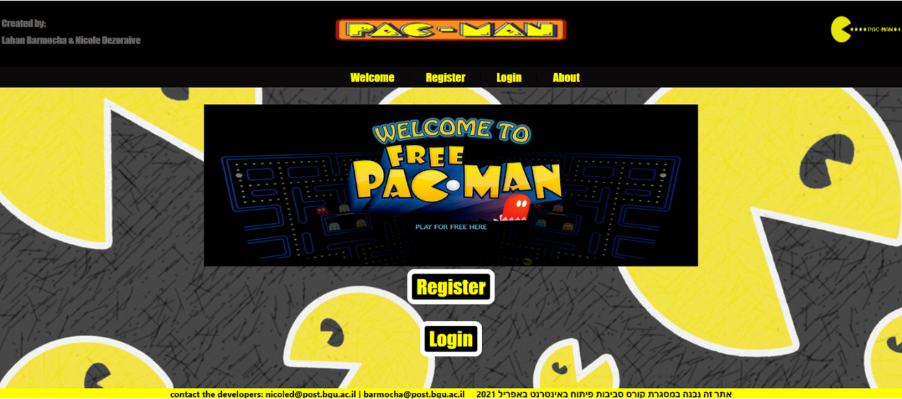](https://github.com/Web-Development-Environments-2021/Assignment2_313584294_205590656/blob/master/resources/WelcomePage.png)

**Register Page:**

[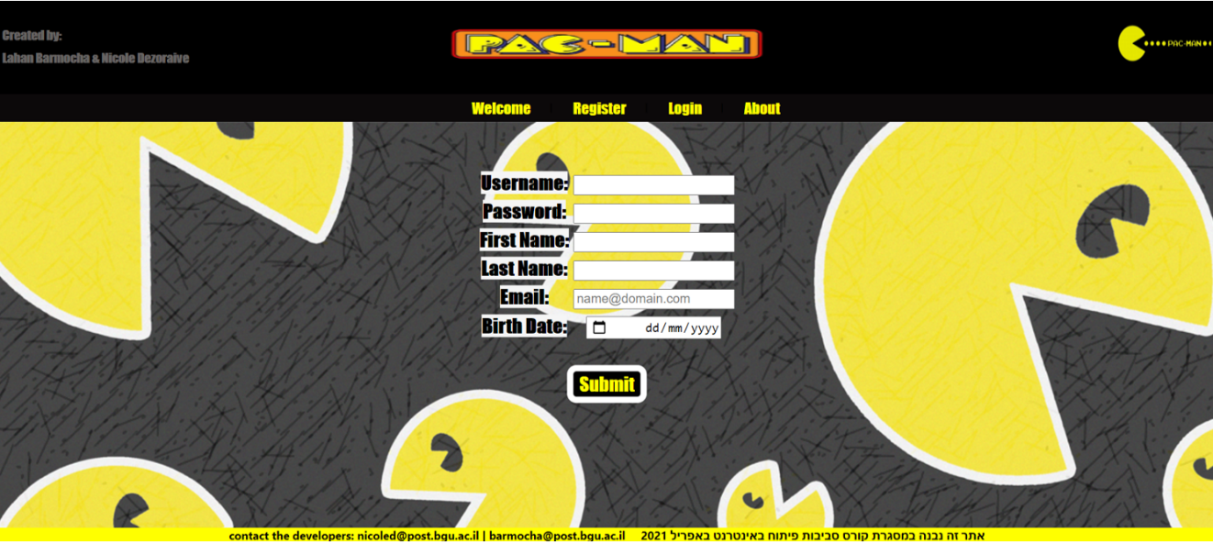](https://github.com/Web-Development-Environments-2021/Assignment2_313584294_205590656/blob/master/resources/RegisterPage.png)

**Register Error Page:**

[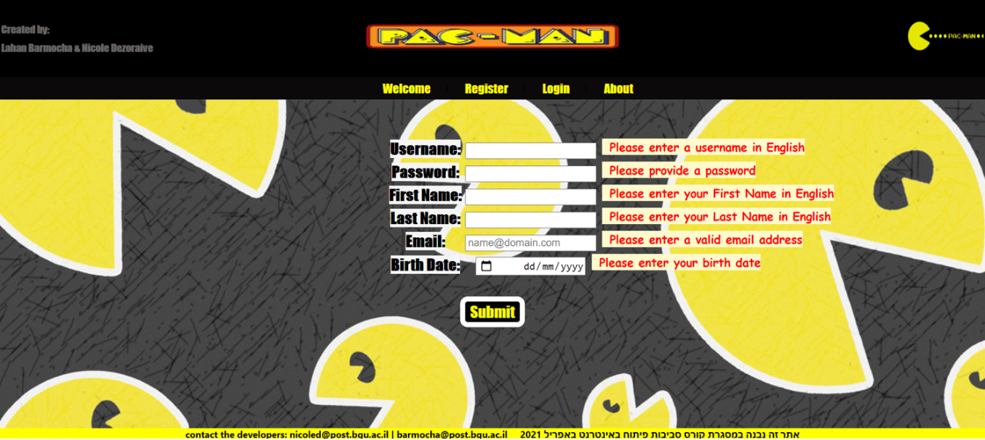](https://github.com/Web-Development-Environments-2021/Assignment2_313584294_205590656/blob/master/resources/RegisterPageError.png)

**Login Page:**

[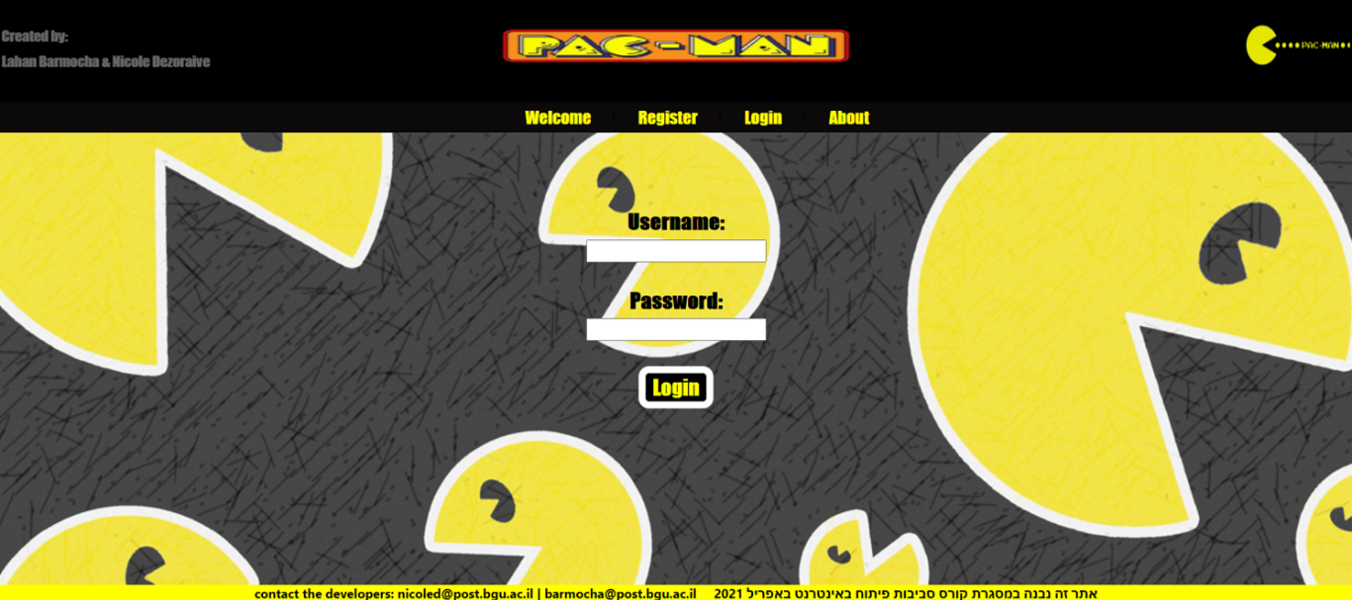](https://github.com/Web-Development-Environments-2021/Assignment2_313584294_205590656/blob/master/resources/LoginPage.png)

**About Page:**

[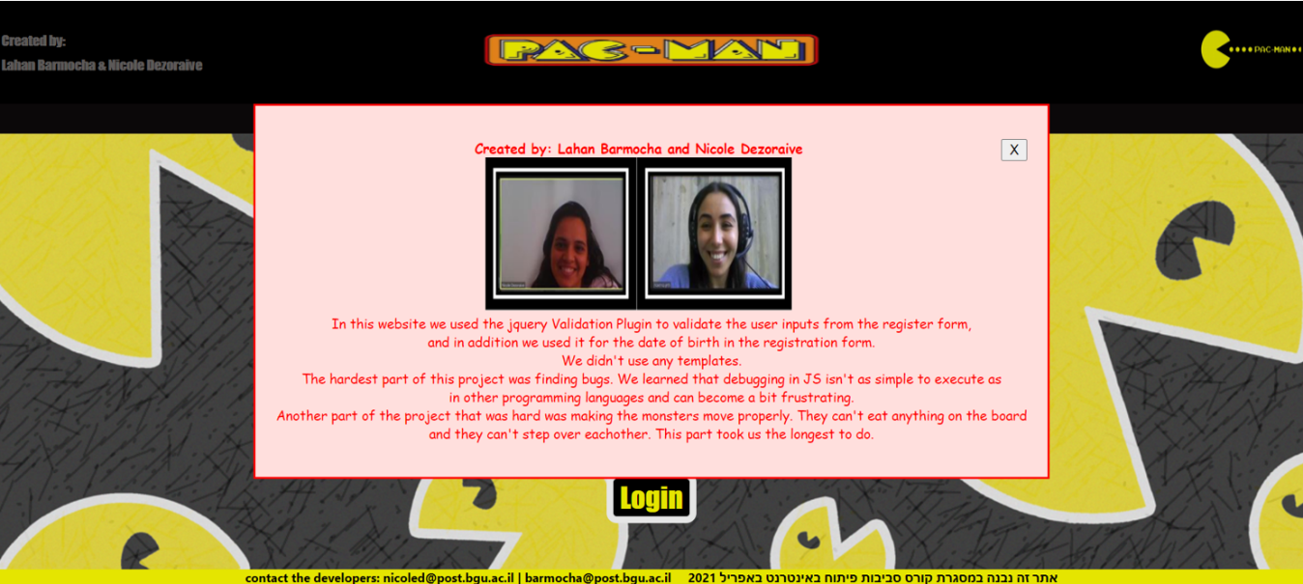](https://github.com/Web-Development-Environments-2021/Assignment2_313584294_205590656/blob/master/resources/AboutPage.png)

**Setting Page:**

[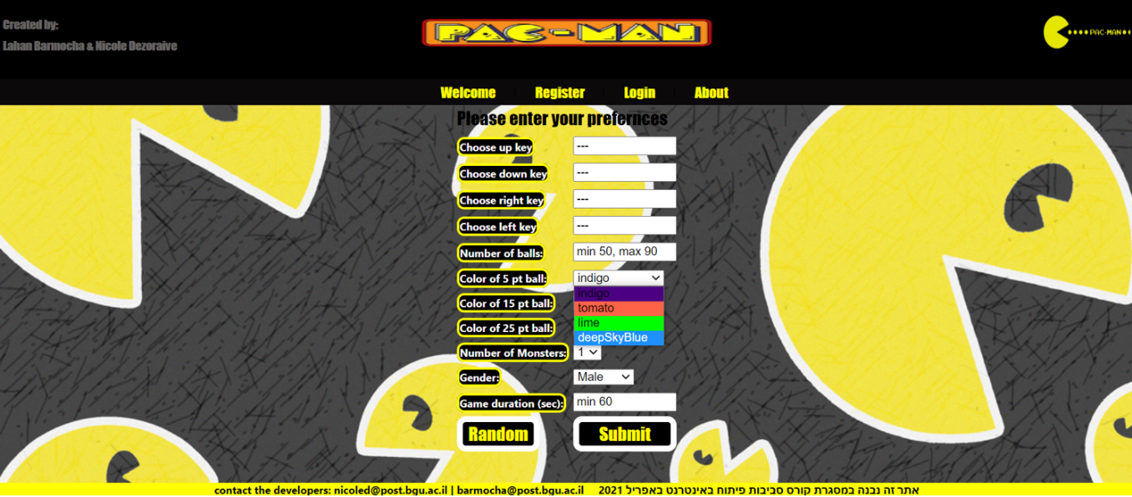](https://github.com/Web-Development-Environments-2021/Assignment2_313584294_205590656/blob/master/resources/SettingsPage.png)

**Setting Random Page:**

[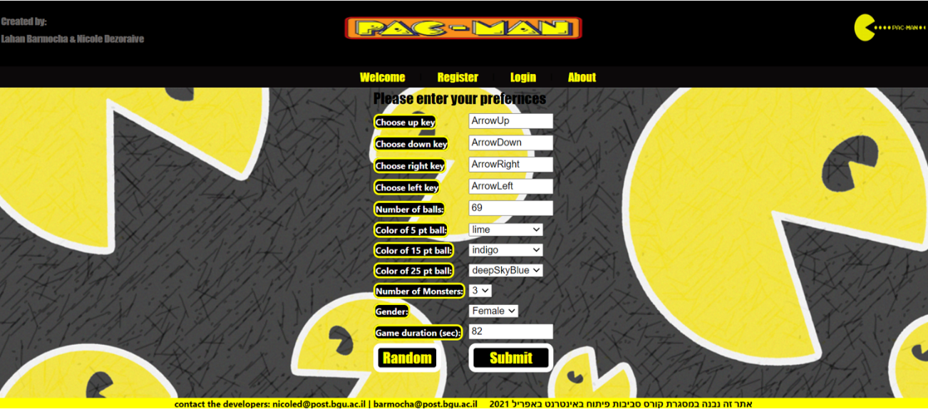](https://github.com/Web-Development-Environments-2021/Assignment2_313584294_205590656/blob/master/resources/SettingsPageRandom.png)

**Ready Page:**

[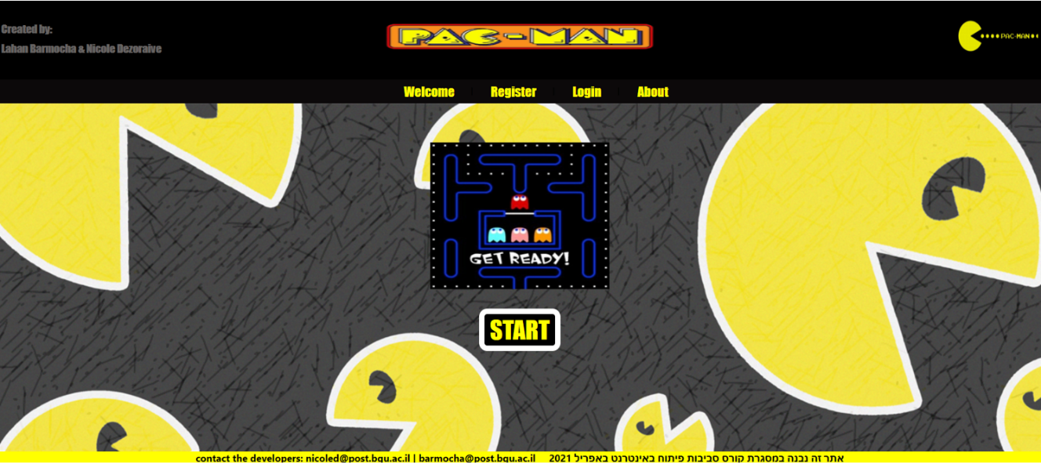](https://github.com/Web-Development-Environments-2021/Assignment2_313584294_205590656/blob/master/resources/GetReadyPage.png)

**Game Page:**

[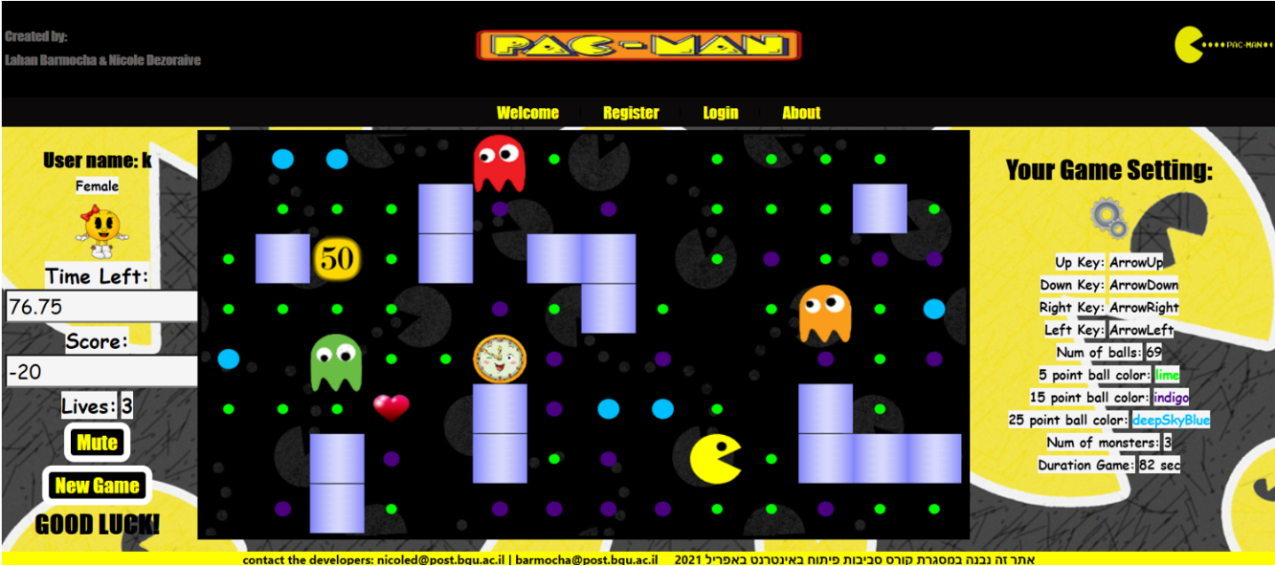](https://github.com/Web-Development-Environments-2021/Assignment2_313584294_205590656/blob/master/resources/GamePage.png)

**Hope you enjoy our game :)**